**PROGRAMMING IN C**

**ASSIGNMENT ON**

**STRING HANDLING FUNCTIONS**

**SUBMITTED BY:**

# ALEN JOSEPH

Roll no:7 BCA 1st year

**WHAT IS A STRING?**

In C programming a string is a sequence of characters terminated with a null character. In other words, a string is a data type used in programming. it is used to represent text rather than just numbers.

It consists of a set of characters that can also contain spaces and numbers. Typically programmers must enclose strings in quotation for the data to be recognized as a string and not a number or variable.

# **STRING HANDLING FUNCTIONS**

String handling functions are those which can be used to carry out many of the string manipulations. These functions are packed in the **string.h** library.

**1.strcat():**

It is used to combine 2 strings

Syntax:

## strcat(string1,string2)

Example:

Code:

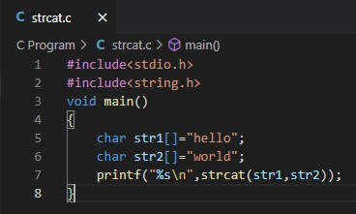

Output:

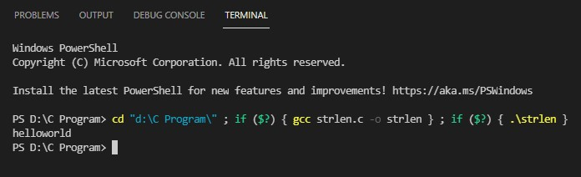

**2.strlen():**

This function will return the length of the string passed to it Syntax:

## strlen(string1)

Example:

Code:

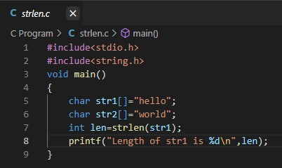

Output:

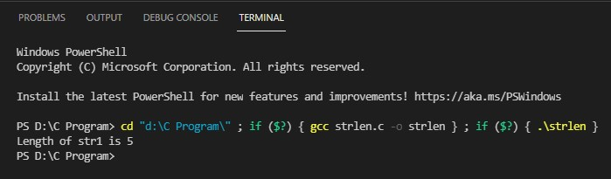

**3.strcmp():**

This function will return an ASCII difference between the first unmatching character of two strings.

Syntax:

## strcmp(string1,string2)

Example:

Code:

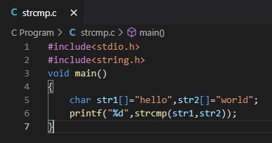

Output:

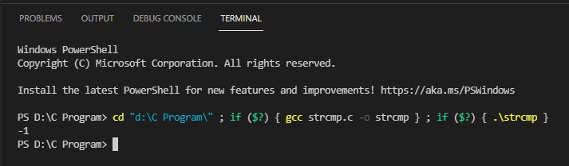

**4.strcpy():**

This function will copy second string argument to the first string argument

Syntax:

## strcpy(string1,string2)

Example:

Code:

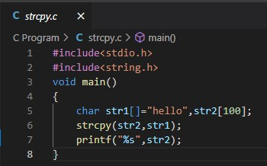

Output:

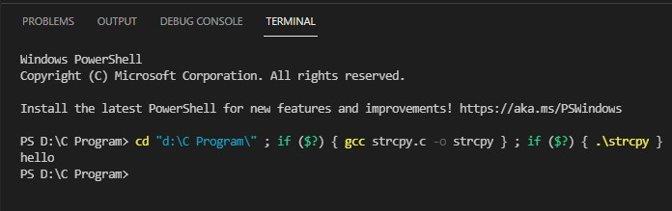

**5.strrev():**

This function will reverse the given string.

Syntax:

## strrev(string1)

Example:

Code:

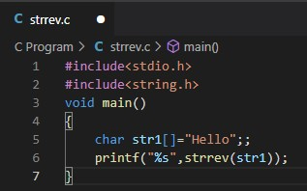

Output:

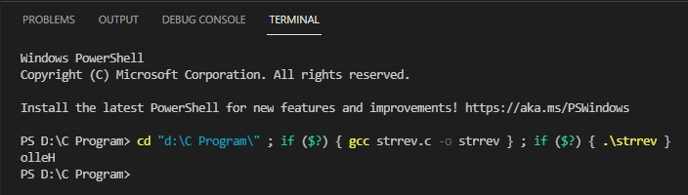

**6.strupr():**

This function will change all lowercase letters of the given string to uppercase

Syntax:

## strupr(string1)

Example:

Code:

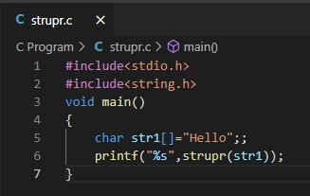

Output:

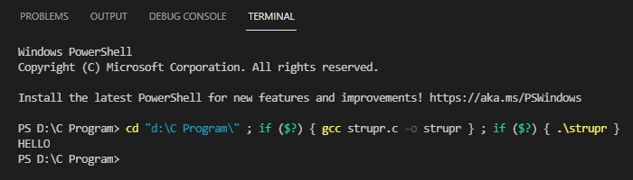

**7.strlwr():**

This function will change all uppercase letters of the given string to lowercase

Syntax:

## strlwr(string1)

Example:

Code:

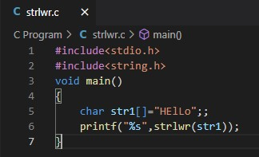

Output:

